Wind’s End Design Document

A game designed for the Personal Computer
Produced by: Matt Fugere, Randi Pawson, Christopher "Goober" Ramsley

Latest Revisions (02-01-2010)

Table of Contents

Player Creation

Player Skills

Drama Manager

Drama Manager Variables

NPC Allies

Abstract

Wind's End is a role playing game with a dynamically generated story which utilizes a drama manager and has an argument-based conversation system. The player, an adventurer, will be thrown into a fictional town which has recently been suffering from a lack of food. Goblins have moved into the nearby farms, thieves are raiding supplies, and a deadly cult is building in power. The goal of the game is to prevent the town’s demise, through force and/or persuasion. The player can approach the situation in a variety of ways, and the world will react appropriately. Convincing enemies to join you, pitting those enemies against each other, killing them all yourself, gathering a band of allies, and many more options are at the player’s fingertips. The drama will build as events play out, eventually culminating in some final conflict, be that a giant battle, or a momentous conversation.

Table of Contents

Player Creation ..................................................................................................................... 3

Player Skills .......................................................................................................................... 4

Factions ................................................................................................................................. 5

Major Autonomous NPCs..................................................................................................... 6

Incidental NPCs.................................................................................................................... 6

NPC Variables ...................................................................................................................... 7

Story Setting ......................................................................................................................... 8

World Areas ......................................................................................................................... 8

Conversation System............................................................................................................. 12

Drama Manager .................................................................................................................... 13

Drama Manager Variables ................................................................................................... 14

Drama Manager Actions ...................................................................................................... 14

NPC Dramatic Goals ............................................................................................................ 15

Faction Dramatic Goals ....................................................................................................... 16

NPC Allies ........................................................................................................................... 17

Game Ending ........................................................................................................................ 18

Appendix I: Diagrams .......................................................................................................... 19

Revision History .................................................................................................................. 20

Credits ................................................................................................................................. 21

Player Creation
The Player’s Character: When the game begins, the player is presented with a few dialogue boxes. These boxes describe the current world in which the player will start off in. The game will then ask the player which gender he is so that it will display an appropriate model for the player.
You have control from the very first second by choosing your past experiences and gender.

Adventurer Combat Skills: Every adventurer has 4 combat skills that he knows or can learn throughout the game. These combat skills are: evasion, thunder clap, chain lighting, and rejuvenation. The two skills thunder clap, which gives the adventurer the ability to stun close units, and evasion, which allows the adventurer to avoid taking damage for a certain amount of time, thus granting the adventurer time to escape, heal, or kill the remaining enemies. Chain lighting, on the other hand, will deal damage to one target and depending on the level of this skill will jump to other units close by. Rejuvenation is the skill that allows the adventurer to heal. The adventurer can cast this upon himself or units in his party.

Past Experiences: Since the player will be controlling an adventurer, it is important to discover what this adventurer has done in the past. In order to do this, the player will be presented with a series of situations and has to answer how he overcame each situation. This will let the player know his adventurer status before entering the game and it will also serve as starting point for each of the skills the adventurer can have.

Situation 1: Who were you before you became an adventurer?
Choices:
- I was a peasant. (Beg)
- I was an aristocrat. (Mock)
- I was a scholar. (Reason)

Situation 2: What caused you to become an adventurer?
Choices:
- I wanted to find fame and fortune. (Brag)
- I wanted to help people. (Rejuvenation)
- I wanted to learn new things. (Chain Lighting)

Situation 3: What was your greatest achievement?
Choices:
- I escaped an infested orc cave. (Evasion)
- I stared down an ogre. (Intimidate)
- I slew a battalion of invading soldiers. (Thunder Clap)

Player Skills
Types of Skills: A player at all times will have a total of 9 skills. These 9 are split up into 2 different categories of: conversational and combat. Of the 9 skills, 5 of them will be conversational skills that include the different stances the player can take during a conversation, such as mock. The combat skills make up the last 4 skills the player can have. These skills were described above in Adventurer Combat Skills.
You gain 3 points at every level, allowing you full control to advance your unique character.

Leveling Skills: At the beginning of the game, the player starts with each of these 9 skills at their default level of zero with 1 point allotted into the 3 skills that he choose when creating his adventurer. By defeating enemies or winning conversations, the player gains a pre-determined amount of experience. This experience will add up until the player is able gain a level. At each level, the player will gain an additional 3 points which he can place into any of the skills. Once a skill is improved, the player can use it more efficiently. For conversational skills, this would mean that the player will gain an extra advantage during a conversation by either losing by less or winning by more. Combat skills, if improved, will simply make that skill more effective and the observational skill will give the player more information about what he happens to be observing.
Become a conversational whiz, a combat guru, or a Jack of all trades. Just beware to not put all your eggs in one basket.

Skill Limitations: When adding new points into any of the skills, the player will only be able to learn a skill once every other level. This allows players to become more well rounded versus only learning one skill every level. The skills will not be allowed to be higher than level 5.

If you are level 4, your reason skill can only have 2 points into it.

Player Level Cap: Although the player's skills will cap out at level 5. The player will cap their level once they reach level 10. This means that the player will never earn enough points to be able to max out all of his skills.
Factions

Townsfolk: The townsfolk faction consists of all of the main NPCs that the player can expect to find inside the town. The town is split up into three areas, which are the upper class, lower class, and town square. By nature, the townsfolk are not hostile to the hero and can usually be convinced to join the adventurer on his journey.

Militia: While the militia usually does not reside within the town due to the unfortunate circumstances, it has decided to make camp in the militia district. The militia, like the townsfolk, will not attack the player automatically as well since its job is to try to help rid the town of the evil surrounding it.

Cult: Nobody in town knows exactly who is or who is not a member of the cult, allowing the faction to work under cover within the town boundaries. The cult may or may not attack the player when they first meet, depending on its feelings at the time towards the hero.

Goblins: The goblins have long been pushed away to reside in the forest near the town. While they usually do not cause much trouble, the townsfolk are seeing their mischief more and more each day. To put a stop to the goblins, the townsfolk and the militia have become hostile towards them, causing the goblins to be very wary of the adventurer.

Thieves: While the thieves used to reside in the town square and lower district of town, since the militia has arrived, they have escaped to the northern reaches into the mountains. Since it is not their nature to just pick up and leave, townsfolk will still see a few agents wandering about in the lower district.

Thief Defectors: Unknown to the townsfolk, a thief defector, Rissa Emmor, has managed to take command of a small but loyal group of thieves. These thieves believe in their right to work under cover in the lower class section of town and refuse to stop the activities which are making them wanted by the militia.

Food Supply: Since the town is having severe problems with the food supply, each faction does keep a strict eye on the supplies that it still has available. If it is unable to obtain supplies for too long, its storage of food will deplete and will usually cause its members to act unreasonably or even die. On the other hand, if it manages to keep a steady supply of food ready to itself, its leader might even cease certain activities.

Major Autonomous NPCs

Name | Story Role | Combat Role | Description | Ultimate Goal
Neil Riese | Militia Commander | Knight | Stubborn, Chivalrous | To protect the town (All town zones occupied by militia)
Melinda Gold | Baroness |  | Manipulative, Flirtatious, Mean | To win the heart of the knight commander or player
George Emmor | Thieves’ Guildmaster | Rogue | Stylish, Egotistical | To front a giant crime syndicate
Rissa Emmor | Thief Defector | Rogue | Power hungry, Selfish, Charismatic | To become rich and famous
Anne Sidora | Cult Leader | Necromancer | Deceitful, Friendly | To spiritually cleanse the world
Nak Brightfeather | Goblin Chief | Shaman | Hyper, Mischievous | To support his people and see them prosper
Edward Snair | Shopkeeper | Alchemist | Nice, Clumsy | To solve the world’s problems through his potions
Richard Snair | Innkeeper | Bard | Cranky, Wise | To have some peace and quiet
Jonathan Mostan | Hunter | Archer | Mean, Dedicated, Reckless | To be a praised hero who slays dragons and saves damsels
Sister Sierra | Priest | Priest | Preachy, Superstitious | To have everyone in the town attend her sermons and listen
Kendra Epera | Blacksmith | Fighter | Cowardly, Spiritual | To serve in the militia
Joey Tielom | Child |  | Annoying, Imaginative | To grow up and be like George Emmor
Meredith Neintir | Magic Shopkeeper | Sorcerer | Naggy, Gossipy | To become the new baroness

Incidental NPCs

Militia | Bandit | Cultists | Goblins | Peasants
Captain | Thug | Zombie | Warrior | Farmer
Soldier | Spear thrower | Banshee | Shaman | Townsfolk
Archer | Thief | Warlock | Sappers | Child

NPC Variables

Each NPC will have these variables associated with them.

Variable | Type | Category | Description
Dead | Boolean | Stats | True - NPC is dead  False - NPC is still alive
Goals | Object | Stats | The goals that the NPC has.
Faction | Object | Stats | The factions that the NPC is a part of.
Faction Leader | Boolean | Stats | True - Is the leader of the faction.  False - Is not the leader.
Importance | Integer | Stats | -10: Trash NPC that has no meaning of life  10: Main villain
Virtue | Integer | Traits | -10: Heartless evil bastard  10: Saintly
Motivation | Integer | Traits | -10: Super lazy, scared  10: Loves killing things, everything
Combat Power | Integer | Traits | -10: A kitten could kill you  10: You are really strong
Argument Power | Integer | Traits | -10: Terrible at arguing  10: Highly convincing
Disposition | Integer | Relations | -10: Hated enemy, nemesis  0: Acquaintance  10: Best friend forever
Respect | Integer | Relations | -10: They are just a weakling  0: About as good as me  10: Holy crap that guy is awesome
Happiness | Integer | Moods | -10: Super depressed, suicidal  10: Super happy, could kiss a pig
Hostility | Integer | Moods | -10: Terrified, running away, trying to escape  0: Calm  10: Smash everything, pissed off

Information: NPCs will also have information that can be used to evaluate goals and can be given to the player. Each piece of information will be associated with a subject that corresponds to the list of subjects from which the player can choose when asking for information, and a text description explaining the piece of information (e.g. a piece of information about goblins with the description “There are goblins stealing food from the farms.”).

Story Setting

Wind's End Bastion was first founded when the king of the time awarded the land to a travelling hero for his honorable undertakings. Along with the land, the hero was given the title of Baron and slowly over time, many travelers who came across Wind's End Bastion have decided to call it their home. This story takes place a few decades later, when Wind's End Bastion is under the watch of the heiress of the original hero, Melinda Gold, and a squad of the king's own, commanded by Knight Neil Riese.

Although this quiet town has not seen many fights, an unfortunate turn of events has taken place. Over the past year, Wind's End has been suffering a severe drought, leaving many of the citizens barely enough to feed themselves. Some have seen this as an omen, others as corruption of the nobles. The beautiful woman, Anne Sidora, who lives near the outskirts of town is one of the many who believe that the drought was caused because of the lack of rituals performed to Olkia, the goddess of land. She has convinced many of the townspeople of this fact and persuaded many of them to do these rituals to protect their families from harm.

Unlike Mistress Sidora, George Emmor, the leader of the resident thieves, believes that the recent addition of the militia squad is responsible for the lack of food. Although many know of the thieves activities, there had been little violence to acquire the supplies needed for him and his friends. However, the Commander Knight has tried to change the unwritten pact between the thieves and traders, hunting and executing caught thieves.

Another group who resides in the forest near Wind's End is particularly interesting. Lead by Nak Brightfeather, the goblin horde who are usually wreaking mischief on unwary travelers, have begun to steal what food they can get from the local farms. This is less due to their
mischievous natures but more so they will be able to survive in such a barren time.

World Areas

Area | Residents
Town (Militia District) | Neil Riese, Militia
Town (Upper Town) | Melinda Gold, Sister Sierra
Town (The Market) | Edward Snair, Richard Snair, Kendra Epera, Meredith Neintir, Jonathan Mostan
Town (Lower Town) | Joey Tielom, Anne Sidora, Rissa Emmor, Peasants, Thieves
Farms | Farmers, Goblins
Forest | Nak Brightfeather, Goblins
Mountains | George Emmor, Thieves

Militia District: The militia district contains Wind’s End Bastion’s primary fortifications. A large castle is the main focus of the area, and smaller military barracks are set up nearby.
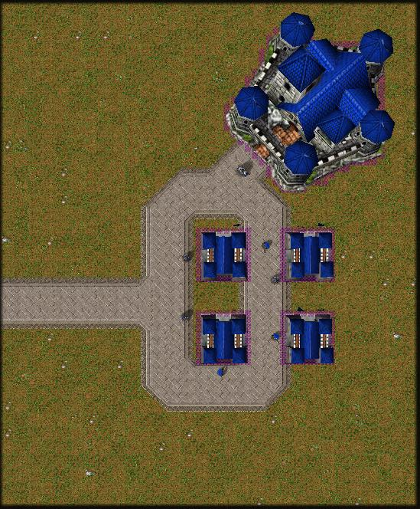

Upper Town: This is where the rich townsfolk live. The baroness’s manor resides here, as does the church.
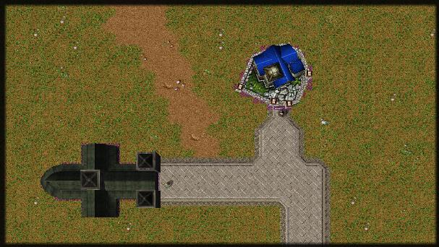

The Market: The market contains the shops and stands that keep the town running. The majority of the main NPCs spend most of their time in the market.
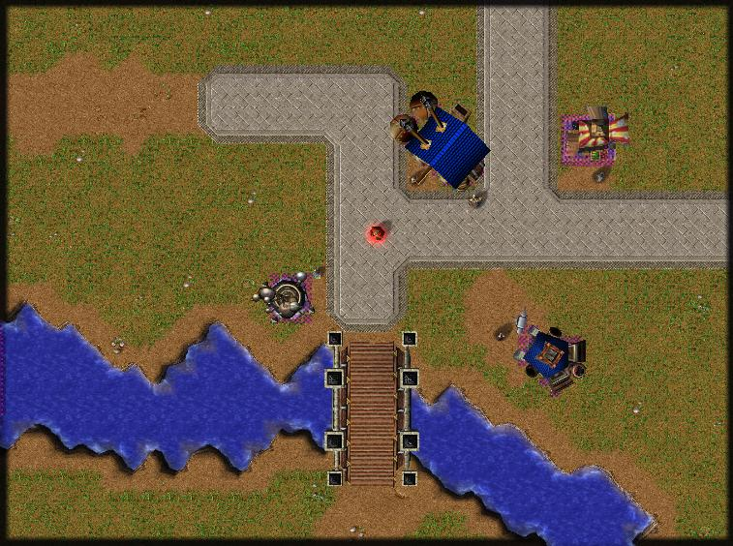

Lower Town: The poor district. Most of the common people live here, and it houses an disproportionate number of hidden thieves.
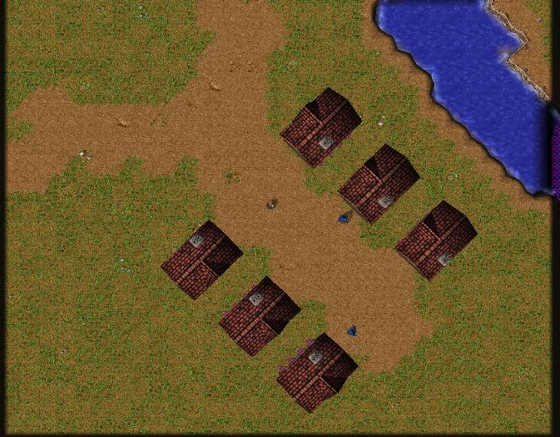

The Farms: The farms are the main source of food for Wind’s End Bastion, and are a short distance west of town.
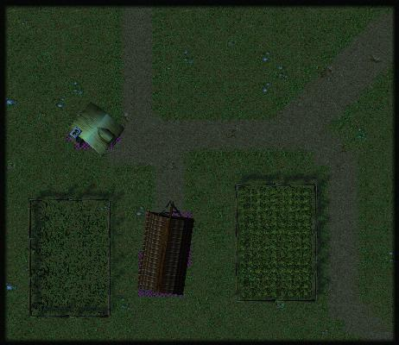

The Forest: North-west of town, the forest is home to the goblins.
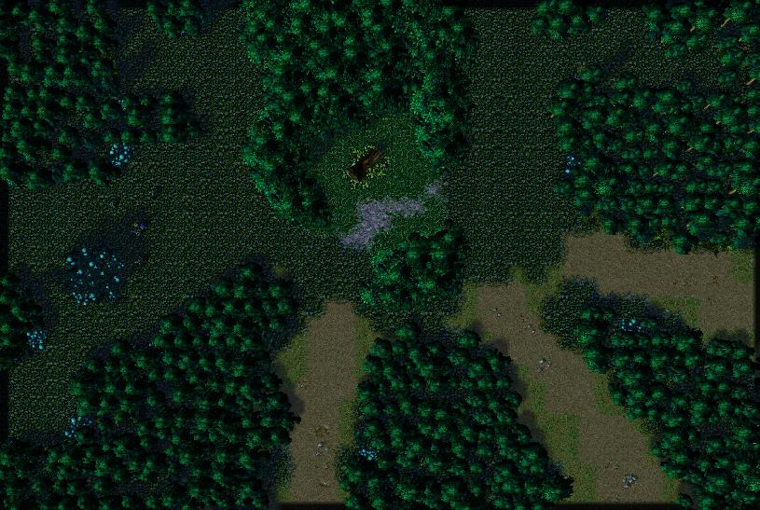

The Mountains: North of town, the mountains are the base of operations for the thieves.
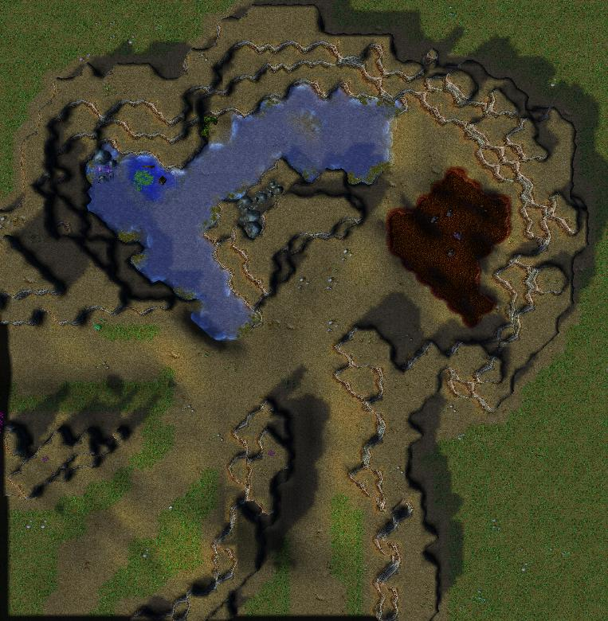

Pathways: Between the town, farms, forest, and mountains lie roads. These roads are skipped over by narration if nothing interesting happens on the way, but are used if anything interrupts the player’s journey.

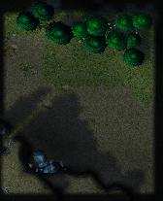

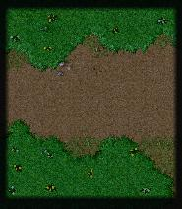

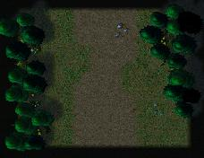

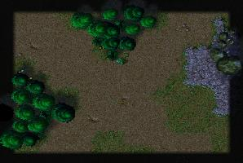

Conversation System

Choose your topic wisely, you won't get another chance to talk for a few seconds.
Player Initialization: When the player wishes to begin a conversation with an NPC of his choice, he can select that NPC and use the talk ability. At the start of the conversation, the player gets to choose an action (see Actions section). Once the player has chosen an action, the NPC can either choose to "Agree" with the player on the action and subject or to "Dispute,” which allows the player and the NPC to argue over the topic.

Actions: The actions which can be chosen when starting a conversation are limited. The choices are: ask for information, request assistance, slander, praise, and demand surrender. Once the player chooses an action, he is given a subject at which he wants the action to be directed. A table of subjects that are relevant to each action is below.

Action | Subject
Ask for Information | Town, Militia, Characters, Thieves, Cult, Goblins
Request Assistance | Supplies, Companionship
Slander | Townsfolk, Militia, Characters, Thieves, Cult, Goblins
Praise | Townsfolk, Militia, Characters, Thieves, Cult, Goblins
Demand Surrender | None

Argument: If the NPC decides to "Dispute" the action that was chosen, an argument will begin. During the argument, the player and NPC will each choose a stance to take without the other’s knowledge, and then both will be displayed. Depending on the stances chosen, either the player or the NPC will win that round, brining the victory meter closer to either side. If the meter reaches one side, that side wins. If it has not reached either side after a given round, a new round will begin, and the player and NPC will again select stances, which will be compared.

Winning or Losing: The different stances are compared to each other in a rock-paper-scissors style, though higher skill in a given stance and situational modifiers may modify the result. As the argument progresses, the amount by which the winning stance wins will increase, eventually reaching a point where the next time the player or NPC wins a round, he wins the entire argument. By winning the argument, the player may achieve his goal or perhaps even change the NPC’s belief on the subject. No matter the outcome of the argument, the player will not be able to initiate conversation with that same NPC for a few seconds. This system will ensure that an argument will never go on for too long and it forces the player to try to win every argument.

Simply choose a stance. It's that easy.

Drama Manager

Autonomous NPC: The major NPCs do whatever they want based on their own personalities and aspirations, and their assessment of the situation at hand. Minor NPCs also act of their own accord, but can be ordered to help a major NPC.
Exactly one interesting thing is always happening, no more and no less.

NPCs will have states and properties. Each important NPC will have saved states which will know the NPC's goals and aspirations, while its personalities and emotions (see NPCs) will be saved as properties.

Each NPC will use a goal-based system to determine its next action, leading to natural emergent development of the game world. NPCs will update their goals at the end of each scene.

World Drama Level: The world will have a level of drama, rated from 1 (Someone’s breathing too hard in Sector 8) to 9 (Demonic apocalypse). This drama level will increase as the game progresses, representing a rise in action.

Dramatic Goals: The goals that a NPC can have will be constricted in order to preserve the dramatic flow, based on the world drama level. NPC goals can be rated from 0 (Loafing about) to 5 (To protect the world from devastation…).

At any given time, exactly one NPC, no more and no less, will have a goal with a rating which matches the world drama level. If no NPCs want to man up to that level with their own goals we make them do it anyway. Every other NPC will have a goal with a rating lower than the world drama level, and it will be impossible to have one higher than that level.

Increasing Drama: The drama level will only increase due to two factors. The first factor being time itself. As time passes in the game, the drama level will react accordingly depending on the current drama level and the amount of time. Combat will also influence the rise of drama level since combat itself is very dramatic.

World drama makes sure that you are never bored.

Drama Manager Variables
These are the variables at which the drama manager is looking.
- World Time
- World Drama Level
- NPC Variables

  - Importance
  - Location
  - Death
  - Combat Power
  - Argument Power
  - Goals
  - Faction Leader
  - Conversation Cooldown

Drama Manager Actions

These are the actions the drama manager can take in the world.

- Arbitrate NPC fights and conversations
- Move NPC to different places
- Change NPC goals
- Add new goals to NPCs
- Activate a new scene
- Change world drama level
- Designate new faction leaders

NPC Dramatic Goals

Examples of Level 0  Doing nothing important | - Go to a place  - Talk with the player  - Stand around  - Talk amongst other NPCs  - Tend shop  - Gossip  - Attack  - Run away
Examples of Level 1  Set up goals | - Become cautious (Richard, Meredith, Kendra)  - Complain to player  - Join a new faction  - Ask player to check on farms (Edward, Sister Sierra)  - Flirt with player (Melinda)  - Join the player (Jonathan)  - Suggest new items (Meredith, Kendra, Edward)  - Help player kill incidental NPCs (Jonathan)
Examples of Level 2  Set something into motion | - Make Commander Knight jealous of player (Melinda)  - Ask player to prove his heroism (Melinda)  - Defend property  - Refuse to tend to shop  - Join the player (Kendra, Sister Sierra, Edward)
Examples of Level 3  Complete a minor goal | - Pit Commander and player against each other (Melinda)  - Join the player (Richard, Meredith, Neil, Rissa, George, Nak, Anne)  - Avenge death (Richard, Neil, Rissa, George, Anne)
Examples of Level 4  Threaten town | - Replace leader of a faction
Examples of Level 5  Final confrontation | - Bring order back to town

Faction Dramatic Goals

Examples of Level 0  Doing nothing important | - Go to a place  - Communicate with the player  - Gossip  - Attack  - Run away  - Stand around  - Talk amongst other NPCs
Examples of Level 1  Set up goals | - Initiate people into the cult (Cult)  - Spread Propaganda (Cult)  - Steal supplies (Thieves)  - Steal crops (Goblins)  - Post guards in town (Militia)
Examples of Level 2  Set something into motion | - Kidnap someone unimportant (Thieves, Cult)  - Send sentries outside of town (Militia)  - Kill incidental NPCs  - Retrieve an artifact (Cult, Goblins)  - Vandalism  - Raiding food when food supply is low (Thieves)  - Occupy farms (Goblins)  - Burn a house in town (Cult)  - Destroy barracks (Thieves)  - Attack minor faction members  - Interrogate townsfolk (Militia)
Examples of Level 3  Complete a minor goal | - Resurrect someone to help (Cult)  - Kill important NPC  - Take prisoners (Militia)  - Send patrols into surrounding areas (Milita)  - Take hostages (Thieves)  - Perform ritual (Cult, Goblins)  - Attempt to mind control an important NPC (Goblins)
Examples of Level 4  Threaten town | - March on town ground (Cult)  - Take over the town  - Declare martial law (Militia)  - Loot and pillage town (Thieves)  - Start having a war in the town (rebellion) (Thieves)  - Curse food that mind controls a bigger population of NPCs (Goblins)
Examples of Level 5  Final confrontation | - Summon demon god (Cult)  - Create a dictatorship in town (Thieves, Militia)  - Consolidate power  - Be in control of all supplies (Thieves, Goblins)

NPC Allies

Gathering Allies: The player has the ability (as stated above in Conversation) to convince NPCs to join his group at any time. Once an NPC has decided to help the player by adding his companionship, the NPC will help the player to explore and in fights. The NPC will not take orders from the player but will try to protect him if it becomes necessary. The player should be cautious when choosing allies because not all people are welcome in certain parts of town and their crimes will not be excused simply because they accompany the adventurer.

It is your job to keep your allies alive during fights. After all, they decided to help because you asked them to.

Losing Allies: The player can lose NPC allies in three different ways. The first way to lose an ally is to make that NPC die in combat. If the NPC does manage to die under the player's control, he will be deceased for the rest of the game. The second way to lose one of your allies is to do an action of which he generally disapproves. One example of this would be to have the innkeeper as an ally, then killing the shopkeeper (his brother). If this happens, the innkeeper would then leave your party and will no longer be your ally. The third and final way to lose an ally is if your actions no longer fulfill his goals. Since your allies are NPCs, they will still be evaluating their goals while in your party. An example would be if the player convinces a NPC to help them solve a problem, such as killing a mutual enemy, and then he completes that goal, the NPC ally might decide to leave the player's party because he has completed his current goal.
Be careful to not upset your allies – they can choose to leave your group.

Game Ending

Ways to End: The game can end in two different ways. First of all, the player does have the option at any point during the game to save the game and then restart from that point. However, if the player manages to die during the game, the game will end immediately. The other way that the game will come to a completion is when the world drama manager decides that the drama level 5 has concluded. This will happen after at least one of the many drama level 5 goals have been completed or thwarted.
Don't rush into battle. There are severe consequences if you aren't quite prepared.

Epilogue: If the player dies and ends the game early, the world drama manager will continue observe the world in the state that the player has left it. The player will then see what the drama manager calculated to be the end state of the world.
That's right. You have the power to see the future (after you die, of course).

Appendix I: Diagrams

UML Diagram for NPCs, goals, and the drama manager:

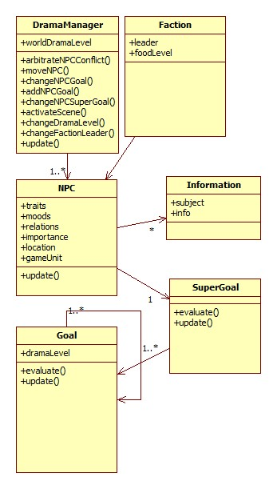

Revision History

10-28-2009

Table of Contents

Player Creation
- Removed Conversational Diagrams

10-13-2009

Player Creation

Player Skills

Failed Conversation
- NPC Allies
- Removed Conversation Mockup
- End of Game
- Terminology
- Added Visual Summaries
- Added Information Section to NPCs
- Map Design for Areas
- Appendix I: Diagrams, UML for NPCs, goals, and the drama manager

10-06-2009

Revised Abstract
- Drama Manager Variables
- NPC Variables
- NPC Personality Model

Conversation System
- Conversation Diagram

9-27-2009

Abstract

List of Incidental NPCs

List of Areas

List of States of Areas

Conversation System
- Revision History

9-22-2009
- Drama Manager
- Story Setting
- List of Important NPCs

Credits

Loading Screen Image - Lord of the Valley by MarcAdamus (Deviant Art)
Advanced Skills by Andrewgosu (The Helper Forums)
Advanced Skills - Hero Abilities by Kitt (The Helper Forums)

